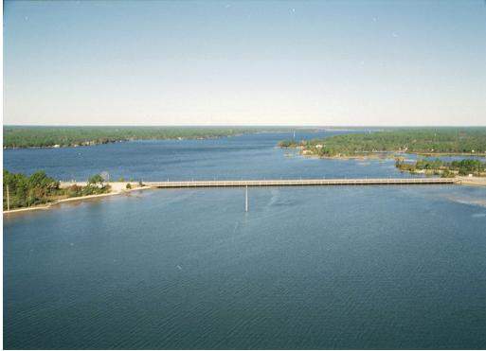
Bay County’s Water System was in violation of the Cross Connection Control Requirement as specified in the State CCR Rules, F.A.C. Rule 62-555.360 & 330. The system began implementing a written cross connection control and backflow prevention program as required on 11/17/20.
What are we doing to meet this requirement? We adopted a new Cross-Connection Control Program (CCCP) plan on 12/15/2020, which meets the 2014 rule. Since adoption, all new Bay County water customers with dedicated irrigation service connections will need to install the required pressure vacuum breaker (PVB) or reduced pressure (RP) backflow device. Our CCCP took a four zoned approach to tackle all the existing 1069 meters that were out of compliance. The four zoned approach is to allow each homeowner ample time to install the required device. Bay County will be in full compliance by 12/31/2025. Please note, all service connections currently have a dual check backflow device that is approved for standard residential connections, however, the device does not meet minimum protection for dedicated irrigation meters as outlined in the 2014 rule. To help customers understand the plan better, Bay County Utilities will have a Q&A sheet available, along with definitions to unfamiliar items and abbreviations found in the new plan. Handouts of the material will also be available at Bay County Utilities Service Office located at 3400 Transmitter Rd.
The sources of drinking water (both tap water and bottled water) include rivers, lakes, streams, ponds, reservoirs, springs, and wells. As water travels over the surface of the land or through the ground, it dissolves naturally occurring minerals and, in some cases, radioactive material, and can pick up substances resulting from the presence of animals or from human activity.
Contaminants that may be present in source water include:
- Microbial contaminants, such as viruses and bacteria, which may come from sewage treatment plants, septic systems, agricultural livestock operations, and wildlife.
- Inorganic contaminants, such as salts and metals, which can be naturally-occurring or result from urban stormwater runoff, industrial or domestic wastewater discharges, oil and gas production, mining, or farming.
- Pesticides and herbicides, which may come from a variety of sources such as agriculture, urban stormwater runoff, and residential uses.
- Organic chemical contaminants, including synthetic and volatile organic chemicals, which are by-products of industrial processes and petroleum production, and can also come from gas stations, urban stormwater runoff, and septic systems.
- Radioactive contaminants, which can be naturally occurring or be the result of oil and gas production and mining activities.
In order to ensure that tap water is safe to drink, the EPA prescribes regulations, which limit the amount of certain contaminants in water provided by public water systems. The Food and Drug Administration (FDA) regulations establish limits for contaminants in bottled water, which must provide the same protection for public health.
Drinking water, including bottled water, may reasonably be expected to contain at least small amounts of some contaminants. The presence of contaminants does not necessarily indicate that the water poses a health risk. More information about contaminants and potential health effects can be obtained by calling the Environmental Protection Agency’s Safe Drinking Water Hotline at 1-800-426-4791.
Some people may be more vulnerable to contaminants in drinking water than the general population. Immuno-compromised persons such as persons with cancer undergoing chemotherapy, persons who have undergone organ transplants, people with HIV/ AIDS or other immune system disorders, some elderly, and infants can be particularly at risk from infections. These people should seek advice about drinking water from their health care providers. EPA/CDC guidelines on appropriate means to lessen the risk of infection by Cryptosporidium and other microbiological contaminants are available from the Safe Drinking Water Hotline (800-426-4791).
In 2024, the Department of Environmental Protection performed a Source Water Assessment on our system. The assessment was conducted to provide information about any potential sources of contamination in the vicinity of our surface water intakes. The surface water system is considered to be at high risk because of the many potential sources of contamination present in the assessment area. The assessment results are available on the FDEP Source Water Assessment and Protection Program website at www.dep.state.fl.us/swapp or they can be obtained from Bay County Utility Services by calling (850) 248-5010.

2024 ANNUAL WATER
QUALITY REPORT
BAY COUNTY
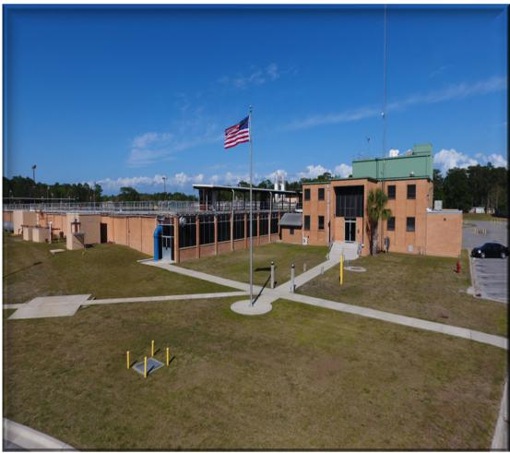
WHAT IS THIS REPORT?
The Environmental Protection Agency requires public water suppliers that serve the same people year-round (community water systems) to provide consumer confidence reports to their customers. These reports are also known as annual water quality reports. This report summarizes information regarding water sources used, any detected contaminants, compliance and educational information. Our water source is surface water drawn from Deer Point Reservoir.
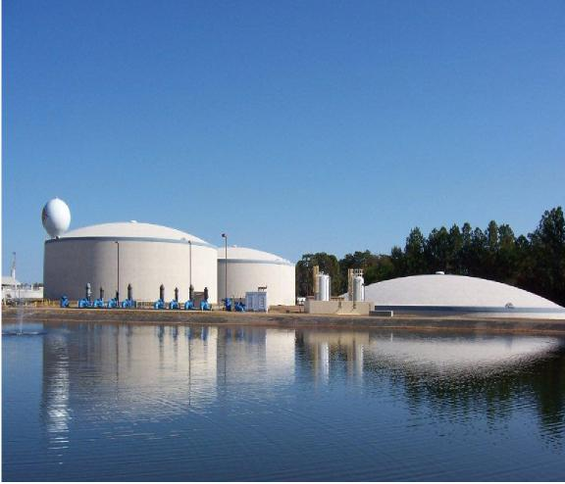
BAY COUNTY UTILITY SERVICES
3400 Transmitter Road
Panama City, FL 32404

The Bay County Water Treatment Plant uses a conventional treatment process consisting of coagulation, flocculation, sedimentation, filtration, pH adjustment, disinfection, fluoridation, and corrosion control. The treatment process includes adding lime occasionally to provide additional alkalinity to the raw water so that it can react with the primary coagulating chemical, ferric sulfate, which is added to remove particles and organics. Polymer is also added to assist in the coagulation process. Sodium Hypochlorite is added to maintain disinfection in the distribution system. The addition of zinc orthophosphate reduces the corrosiveness of the water. Fluoride, in the form of Hy-drofluorosilicic acid, is added as a supplement to prevent tooth decay. Lime is also added at the end of the process to increase the pH. These processes are needed to meet the drinking water standards as set by the United States Environmental Protection Agency (EPA) and the Florida Department of Environmental Protection (FDEP).
Bay County Water Treatment Plant routinely monitors for contaminants in your drinking water according to Federal and State laws, rules, and regulations. Except where indicated otherwise, this report is based on the results of our monitoring for the period of January 1 to December 31, 2024. Data obtained before January 1, 2024, and presented in this report, are from the most recent testing done in accordance with the laws, rules, and regulations.
If you have any questions about this report or concerns about your water utility, please contact Sean Lathrop Water Division Superintendent at (850) 248-5010. We encourage our valued customers to be informed about their water utility. If you want to learn more, please attend any of our regularly schedule Bay County Commission meetings. The meetings are scheduled the first and third Tuesday of each month. Public notices of the meetings are announced regularly publicizing the date, time, and location of the meeting.
Our staff works around the clock to provide top quality water to every tap. We ask that all our customers help us protect our water sources, which are the heart of our community, our way of life, and our children’s future.

In the table below, you may find unfamiliar terms and abbreviations. To help you better understand these terms we've provided the following definitions:
Maximum Contaminant Level or MCL: The highest level of a contaminant that is allowed in drinking water. MCLs are set as close to the MCLGs as feasible using the best available treatment technology.
Maximum Contaminant Level Goal or MCLG: The level of a contaminant in drinking water below which there is no known or expected risk to health. MCLGs allow for a margin of safety. Action Level (AL): The concentration of a contaminant which, if exceeded, triggers treatment or other requirements that a water system must follow.
Maximum residual disinfectant level or MRDL: The highest level of a disinfectant allowed in drinking water. There is convincing evidence that addition of a disinfectant is necessary for control of microbial contaminants.
Maximum residual disinfectant level goal or MRDLG: The level of a drinking water disinfectant below which there is no known or expected risk to health. MRDLG’s do not reflect the benefits of the use of disinfectants to control microbial contaminants.
Nephelometric Turbidity Unit (NTU) - measure of the clarity of water. Turbidity in excess of 5 NTU is just noticeable to the average person.
“ND” means not detected and indicates that the substance was not found by laboratory analysis.
Parts per billion (ppb) or Micrograms per liter (µg/l) – one part by weight of analyte to 1 billion parts by weight of the water sample.
Parts per million (ppm) or Milligrams per liter (mg/l) – one part by weight of analyte to 1 million parts by weight of the water sample.
Picocurie per liter (pCi/L) - measure of the radioactivity in water.
Treatment Technique (TT): A required process intended to reduce the level of a contaminant in drinking water.
Level 1 Assessment – A level 1 assessment is a study of the water system to identify potential problems and determine (if possible) why total coliform bacteria have been found in our water system. Coliforms are bacteria that are naturally present in the environment and are used as an indicator that another potentially harmful waterborne pathogen may be present, or that a potential pathway exists through which contamination may enter the water distribution system.
2024 CONTAMINANTS TABLE

Microbiological Contaminants
Contaminant and  Unit of Measurement | Dates of sampling  (mo./yr.) | MCL /TT Violation Y/N | The Highest  Single  Measurement | The Lowest  Monthly  Percentage of  Samples Meeting  Regulatory Limits | MCLG | MCL | Likely Source of Contamination
Turbidity (NTU) | Jan 24 - Dec 24 | N | 0.40 | 98.4 | N/A | TT | Soil runoff
Turbidity has no health effects. However, turbidity can interfere with disinfection and provide a medium for microbial growth. Turbidity may indicate the presence of disease-causing organisms. These organisms include bacteria, viruses, and parasites that can cause symptoms such as nausea, cramps, diarrhea, and associated headaches. High turbidity can hinder the effectiveness of disinfectants. The Treatment Technique standard requires that 95% of the turbidity readings be at 0.3 NTU or less.
Inorganic Contaminants
Contaminant and Unit of Measurement | Dates of sampling  (mo. /yr.) | MCL  Violation Y/N | Level Detected | Range of Results | MCLG | MCL | Likely Source of Contamination
Barium (ppm) | April –24 | N | 0.0072 | N/A | 2 | 2 | Discharge of drilling wastes; discharge from  metal refineries; erosion of  natural deposits
Fluoride (ppm) | April –24 | N | 0.75 | N/A | 4 | 4.0 | Erosion of natural deposits; discharge from  fertilizer and aluminum factories. Water addi-  tive which promotes strong teeth when at the  optimum level of 0.7 ppm
Nitrate (ppm) | April –24 | N | 0.028 | N/A | 10 | 10 | Runoff from fertilizer use; leaching from  septic tanks, sewage; erosion of natural  Deposits
Sodium (ppm) | April –24 | N | 4.8 | N/A | N/A | 160 | Salt water intrusion, leaching from soil
Stage 1 Disinfectants and Disinfection By-Products
Disinfectant and  Unit of Measurement | Dates of sampling  (mo. /yr.) | MRDL  Violation  Y/N | Level Detected | Range of Results | MRDLG | MCL  or  MRDL | Likely Source of Contamination
Chlorine (ppm) | Jan 24 - Dec 24 | N | 0.82 | 0.69 – 0.97 | MRDLG =4 | MRDL =4 | Water additive used to control microbes
Contaminant and  Unit of Measurement | Dates of sampling  (mo/yr.) | TT  Violation  Y/N | Lowest Running Annual  Average, Computed Quarterly,  of Monthly Removal Ratios | Range of Monthly  Removal Ratios | MCLG | MCL | Likely Source of Contamination
Total Organic Carbon | Jan 24 - Dec 24 | N | <2.0 | N/A | N/A | TT | Naturally present in the environment
Stage 2 Disinfectants and Disinfection By-Products
Contaminant and  Unit of Measurement | Dates of sampling  (mo. /yr.) | MCL  Violation Y/N | Level Detected | Range of Results | MCLG | MCL | Likely Source of Contamination
Haloacetic Acids (five) (HAA5) (ppb) | Jan 24 - Dec 24 | N | 28.5 | ND – 35.3 | N/A | MCL = 60 | By-product of drinking water disinfection
TTHM [Total trihalome- thanes] (ppb) | Jan 24 - Dec 24 | N | 41.4 | 4.1 – 53 | N/A | MCL = 80 | By-product of drinking water disinfection

Lead and Copper (Tap Water)
Contaminant and  Unit of Measurement | Dates of Sampling (mo./yr.) | AL  Violation  Y/N | 90th Percentile Result | No. of sampling sites exceeding the AL | MCLG | AL  Action  Level | Likely Source of Contamination
Copper  (tap water) (ppm) | Sep 23 | N | 0.29 | 0 of 30 | 1.3 | 1.3 | Corrosion of household plumbing  systems; erosion of natural deposits;  leaching from wood preservatives
Lead  (tap water) (ppb) | Sep 23 | N | 0.7 | 0 of 30 | 0 | 15 | Corrosion of household plumbing  systems; erosion of natural deposits

The Federal Environmental Protection Agency has revised the Lead and Copper rule for all public drinking water systems. They have mandated that drinking water systems produce an inventory list of all service line material. The service line is the piping that extends from our water main to the customer’s meter as well as the piping that extends from the meter to the customer’s home. Bay County Utilities has prepared this inventory in accordance with federal regulations. To view this service line inventory, contact Bay County Utilities @ 850-248-5010 or visit https://depedms.dep.state.fl.us:443/Oculus/servlet/shell?command=getEntity&[guid=32.1701215.1]&[profile=Sampling

Corrosion of pipes, plumbing fittings and fixtures may cause metals, including lead and copper, to enter drinking water. To assess corrosion of lead and copper, Bay County Utilities conducts tap sampling for lead and copper at selected sites every 3 years. The most recent set of lead and copper tap sampling is available for review. To view the lead and copper tap sampling data, contact Bay County Utilities @ 850-248-5010 or visit https://depedms.dep.state.fl.us:443/Oculus/servlet/shell?command=getEntity&[guid=32.1614010.1]&[profile=Sampling

Lead can cause serious health problems, especially for pregnant women and young children. Lead in drinking water is primarily from materials and components associated with service lines and home plumbing. Bay County Utilites is responsible for providing high quality drinking water and removing lead pipes, but cannot control the variety of materials used in plumbing components in your home. You share the responsibility for protecting yourself and your family from the lead in your home plumbing. You can take responsibility by identifying and removing lead materials within your home plumbing and taking steps to reduce your family's risk. Before drinking tap water, flush your pipes for several minutes by running your tap, taking a shower, doing laundry or a load of dishes. You can also use a filter certified by an American National Standards Institute accredited certifier to reduce lead in drinking water. If you are concerned about lead in your water and wish to have your water tested, contact Bay County Utilities at 850-248-5010. Information on lead in drinking water, testing methods, and steps you can take to minimize exposure is available at http://www.epa.gov/safewater/lead.

